**Introduction**

This Project has implemented the modern features of Object-Oriented Programming like Modularity, Encapsulation and Abstraction. Also, the data has been stored permanently in Binary Files.

**Modularity**

To make the program modular, the program is divided into a number of Header files and their respective implementation files.



Each header file defines a class and declares it member functions. Their respective implementation files define the member functions of the declared functions.

**Abstraction**

Complete attention has been given for data abstraction for all the users. Each user, apart from having the basic features, also has some special features or rights which the other does not have.

For additional security the Admin has been protected by a single level password: “admin”. In case an incorrect password has been entered, it will keep on reiterating till a correct password is entered.

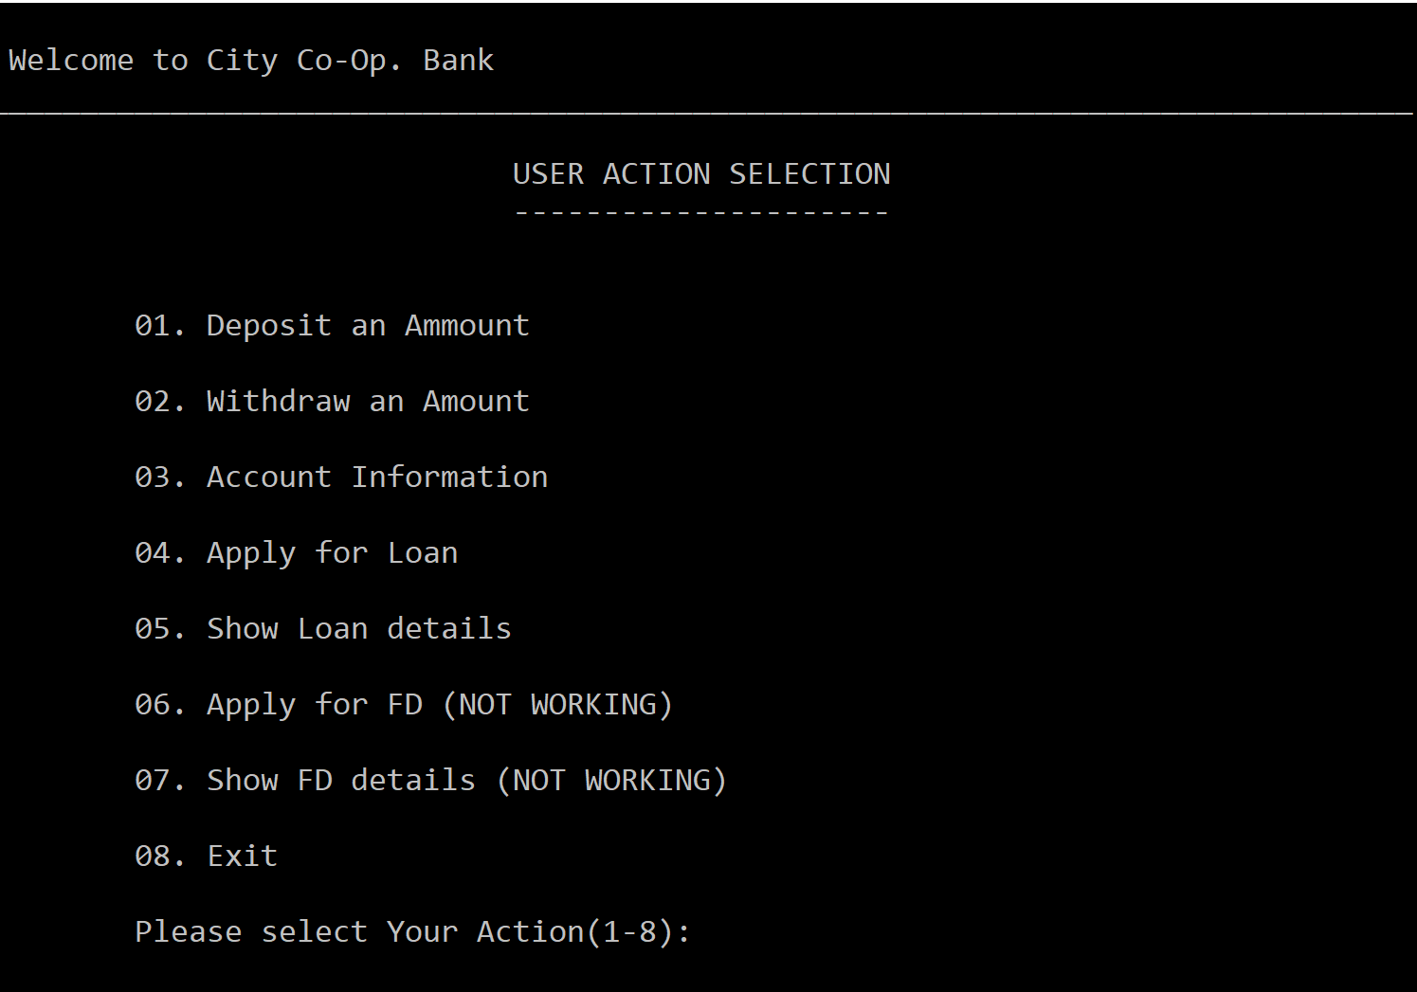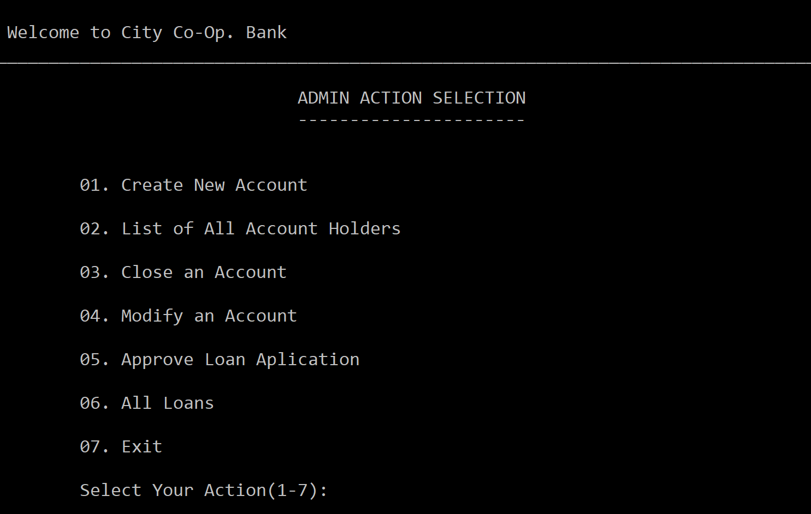We can observe this from the below-mentioned examples.

**Reusability and Efficiency**

This program supports the feature of data file handling. Thus, this code continues regular functionality even after being restarted as all the data has been stored in permanent binary files. The use of Binary files has been done specifically in order to increase efficiency of code.



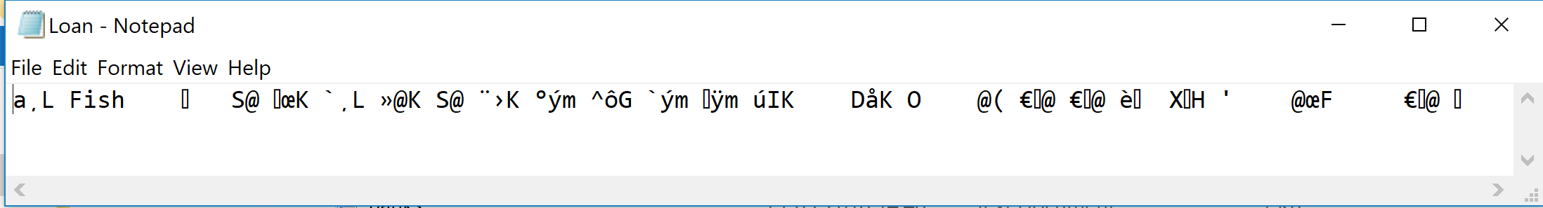

**Flowcharts**

1. The Basic Data Flow



1. Customer Info Management Flow



1. Account Balance Management Mechanism



1. Loan Management Mechanism

